2520090058 practical 6

week-6 Create a client-server application using Named Pipes (FIFOs). The client sends messages and the server processes and responds to them. Analyze FIFO behavior when multiple clients communicate simultaneously.

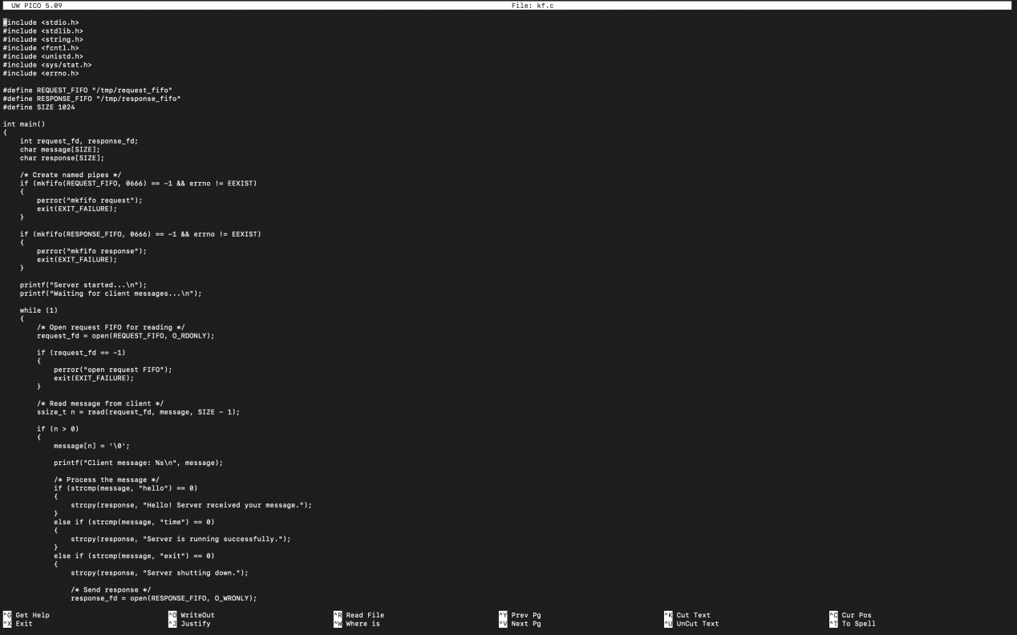
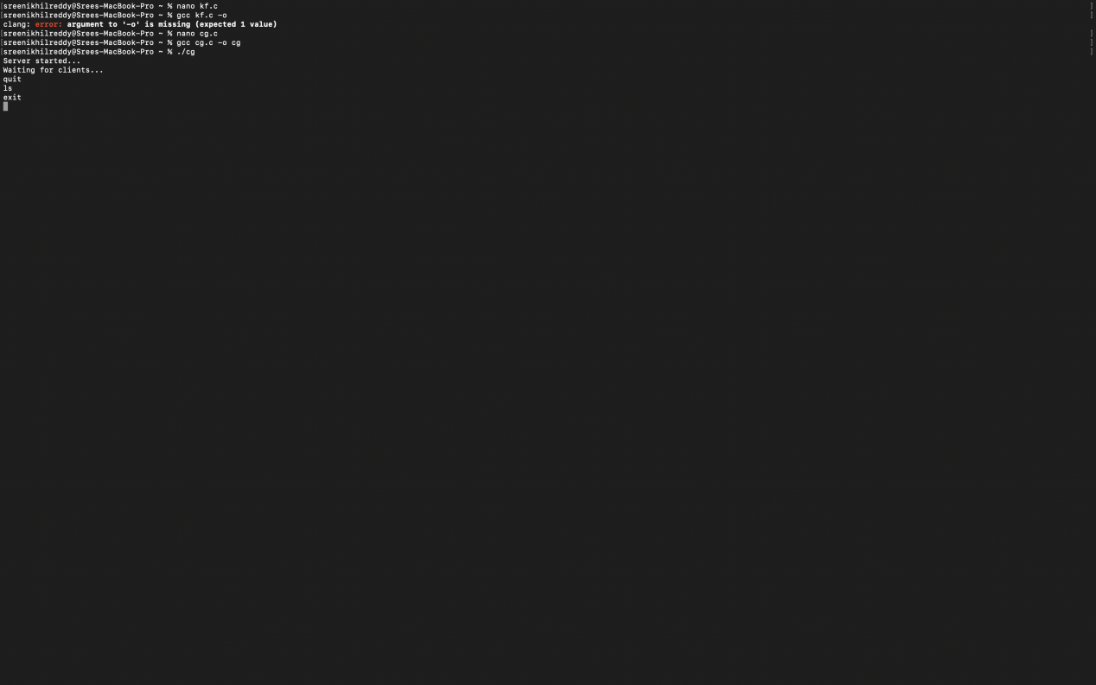

Create a POSIX signal handling program that captures SIGINT, SIGTERM, and SIGUSR1. Demonstrate asynchronous event handling and explain the role of signal handlers.

CODE: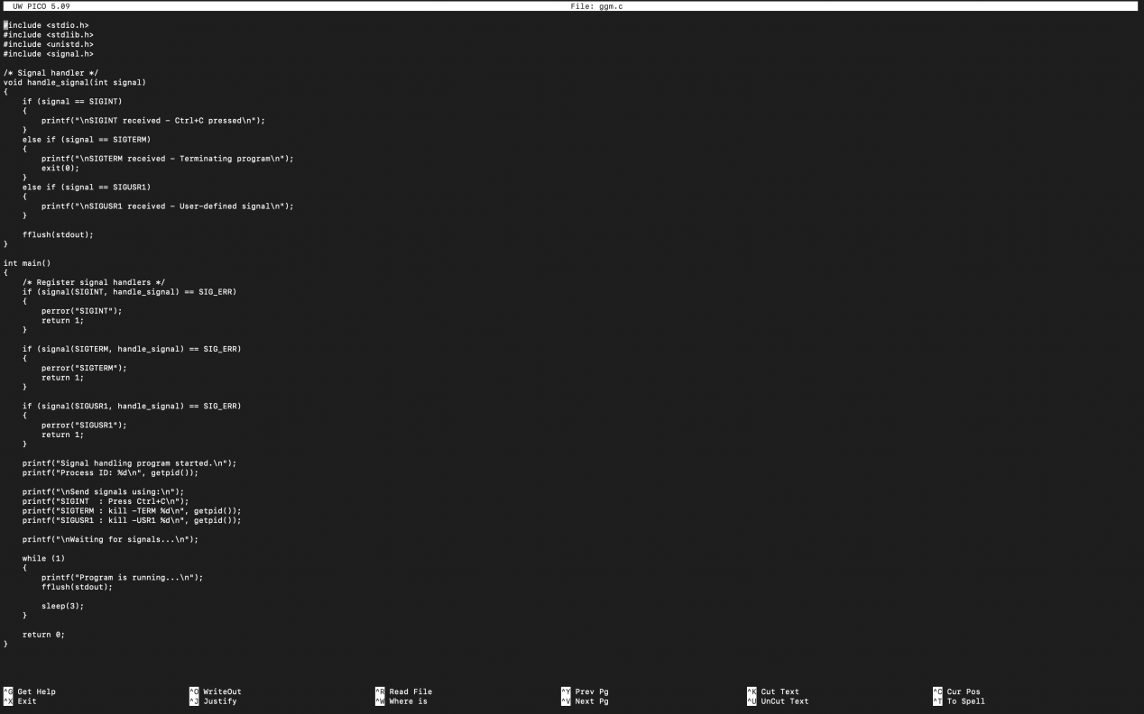
OUTPUT
